Hypertension

Hypertension defined as artery systolic blood pressure at rest of >140 mm Hg and/or diastolic blood pressure of >90 mmHg, affects an estimated 640 million persons worldwide, including approximately 50 million Americans.

High blood pressure is classified as primary hypertension and secondary hypertension.

In Western Medicine
Etiology & Pathology
Primary Hypertension
The exact cause of primary high blood pressure is not known. Below several factors and conditions may play a role in its development, including:
- Smoking  - Lack of physical activity  - Too much salt in the diet  - Too many fatty foods  - Too much alcohol consumption  - Stress | - Lonely  - Older age  - Family history of high blood pressure  - Environment  - Chronic kidney disease  - Adrenal and thyroid disorders

Secondary Hypertension
- Kidney disease
- Adrenal glands
- Pregnancy
- Medications

Hypertensive Crisis Severely elevated blood pressure known to confer a high risk of complications.

Manifestations:

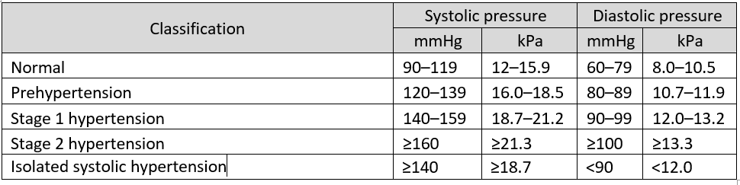

- headaches
- Dizziness
- Vertigo
- Tinnitus
- Fainting episodes
- Anxiety

When to refer to ER?
- Systolic pressure > 180 and/or diastolic pressure > 120
- Blurry vision or other vision disturbances
- Headache
- Dizziness
- Nausea or appetite changes
- Hypertensive crisis

TCM Etiology & Pathology
- Mental stress
- Poor diet
- Excessive phlegm and dampness
- Liver Yang/fire excess and wind stirring
- Liver wind stirring and Qi/blood rebellion
- Kidney water deficiency

Mechanisms of disease:

Excessive Condition:
- Liver Yang/fire uprising
2. Phlegm Obstruction
- Blood Stagnation
- Liver Wind Stirring
- Qi and Blood Stagnation

Deficiency Condition:
- Qi and Blood Xu
- Kidney Yin Insufficiency

Manifestations

Excessive Condition:
- Liver Yang Uprising

Main Symptoms: High blood pressure, dizziness and vertigo, irritable, distending pain of the head and eyes, red complexion, bloodshot eyes, thirsty, dry eyes, insomnia, anxiety, night sweats, headache, sore and weak knees, hot hands and feet, numbness and tremors of limbs. Concentrated dark urine, dry stools, blurred vision, tinnitus

Tongue: red with no coating, peeled

Pulse: wiry, rapid

Treatment Principles: Calm the Liver and drain Fire

Point Prescription: GB34, SP6, Liv2, GB20, DU20, SJ6, HT7

- Liver Fire Flaring

Main Symptoms: High blood pressure, dizziness and vertigo, irritable, flushed face, thirsty, distension in the head and eyes, tight neck and trapezius muscle, dry bitter taste, red face, red eyes, nausea; constipation, dark urine, epistaxis

Tongue: red body, yellow coating, red edges

Pulse: wiry, rapid

Treatment Principles: Calm the Liver and drain Fire

Point Prescription: Liv2, LI4, LI11, GB20, Du20, ST44, ST36, SP6

- Liver Wind Stirring Up Internally

Main Symptoms: High blood pressure, dizziness and vertigo, fainting, sudden onset of headache, high pitch tinnitus, numbness and trembling on limbs, palpitation, insomnia, flushed complexion; thirsty, constipation, scanty urination; anxiety, irritability, hot temper, confusion; stiffness of the tongue, sudden collapse, coma, aphasia, deviation of the mouth and eye, hemiplegia

Tongue: red tongue body, thin yellow coating

Pulse: wiry, slippery, rapid

Treatment Principles: calm liver wind

Point Prescription: GB20, Du20, Liv14, Liv3, GB34, P7

- Phlegm Obstruction

Main Symptoms: High blood pressure, dizziness and vertigo, aggravated heaviness and pain of the head, irritability, dull mind, nausea, heavy frontal headache, somnolence, numbness and heaviness of the limbs, obesity, poor appetite, nausea, feeling in the chest and/or epigastrium

Tongue: white greasy coating, big body

Pulse: slippery and tight

Treatment Principles: Dispel phlegm, transform dampness

Point Prescription: ST40, ST36, P6, SP9, SP6, SP4, GB20, Ren12, Du20

- Head Blood Stagnation

Main Symptoms: High blood pressure, dizziness and vertigo, headache, palpitation, oppression in chest, dark complexion.

Tongue: dark purple tongue, ecchymosis, dark purple sublingual veins

Pulse: irregular, choppy, deep

Treatment Principles: Promote blood circulation to remove blood stasis

Point Prescription: UB17, SP10, UB10, DU20, UB15, UB18, P4

Deficiency Condition:
  - Qi and Blood Deficiency

Main Symptoms: High blood pressure, dizziness and vertigo, aggravated by movement, headache, tinnitus, shortness of breath, muscular weakness, lack of strength, numbness of the hands; fatigued, sallow complexion, insomnia and/or palpitations, blurred vision or dry eyes, floaters, no appetite, loose stools, scanty menses, amenorrhea or late periods; brittle nails, dry skin and hair

Tongue: pale, dry

Pulse: thin, choppy, slightly wiry in the liver position

Treatment Principles: Tonify Qi and blood

Point Prescription: Liv8, Du20, ST36, UB18, UB20, UB23, Ren4, Ren6, GB20, Ht7, KD3, LI11, Liv3, SP6

  - Hyperactivity of Yang due to Yin deficiency

Main Symptoms:

Excess symptoms in upper body-- High blood pressure, dizziness and vertigo, headache, blurry vision

Deficiency symptoms in lower body-- five center burns, palpitations, insomnia, aching of the lower back and knees, tinnitus, forgetfulness, bilateral afternoon malar flushing, bilateral eye dryness

Tongue: red with little or no coating

Pulse: thready, wiry, rapid

Treatment Principles: Nourish Liver and Kidney Yin, subdue Yang

Point Prescription: KD3, Liv3, GB20, P6, SJ17, HT7, Taiyang, Yintang, SP6, HT7, ST36, UB18, UB23

  - Yin and Yang Deficiency

Main Symptoms: High blood pressure, dizziness and vertigo, tinnitus, palpitations, shortness of breath, weakness and aching of the lower back and legs, lack of strength, numbness of the hands, flushed cheeks, hot palms and soles, aversion to cold, pale face, frequent nocturnal urination, impotent, low sexual drive, leg pitted edema, seminal emission

Tongue: red or pale

Pulse: thin and deep

Treatment Principles: nourish kidney Yin and Yang

Point Prescription: Ren4, Du 20, SP 6, Du4, ST36, UB20, UB23, KD3, HT7

Auricular Therapy: Subcortex, Shenmen, Liver, Sympathetic, Heart, Endocrine, Kidney

Hypertension Prognosis:
Hypertension with improper treatments, it can cause to the failure of the other organs such as heart, cerebrum, and kidney.

